# How to add configure run/debug with maven

* **Must Do**
  + **setup JDK**
  + **Maven**
* **FAQ**
  + **Setup 1.8 JDK but it builds as 1.4 or 1.5**
  + **Command too long**

**Raptor IO (Spring)**

clean spring-boot:run -Dspring.profiles.active=default,dev -f pom.xml

**Raptor Batch (Spring Batch)**

specific job you want to run i.e. changeScrubber

clean spring-boot:run -Dspring.batch.job.names=changeScrubber -Dspring.profiles.active=default,dev -f pom.xml

# Must Do

###### setup JDK

File → Project Structure → Project Settings → Project

change JDK to be 1.8, which support most/all of our projects

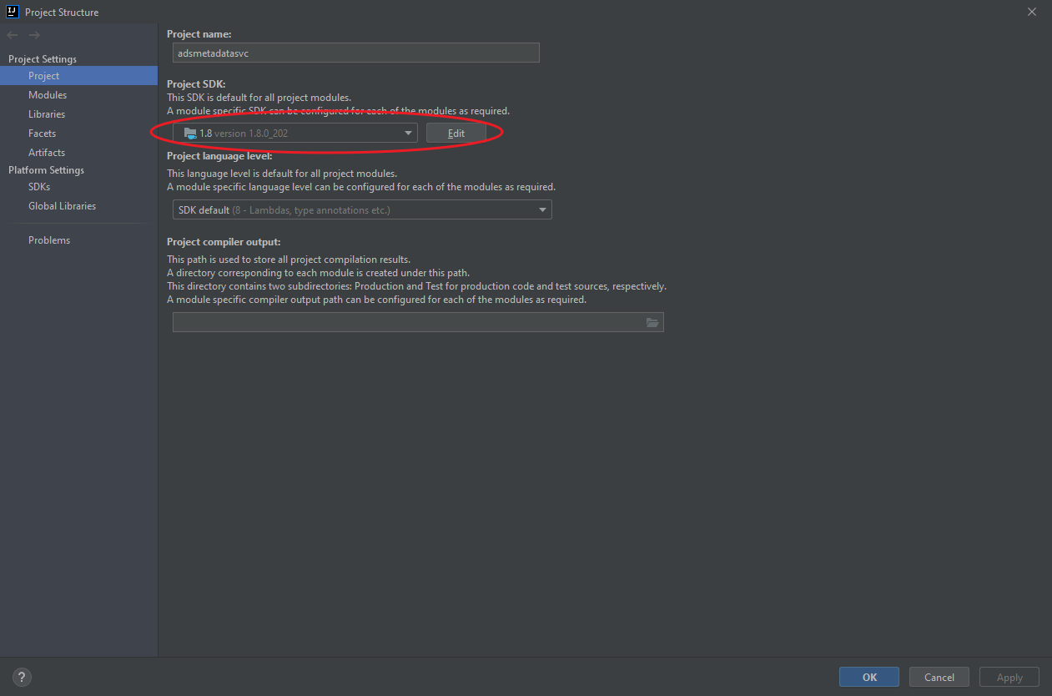

###### Maven

Go through the [onboarding doc](https://docs.google.com/document/d/1blrtaiNEQYfKnJmCDNDdRBXtuhcnIvdOtjXNyFWdvu4/edit) for latest setttings.xml (in wiki of Ads Org onboarding doc, **another one)**. If you put it in differencent localtion, set up as snapshot below

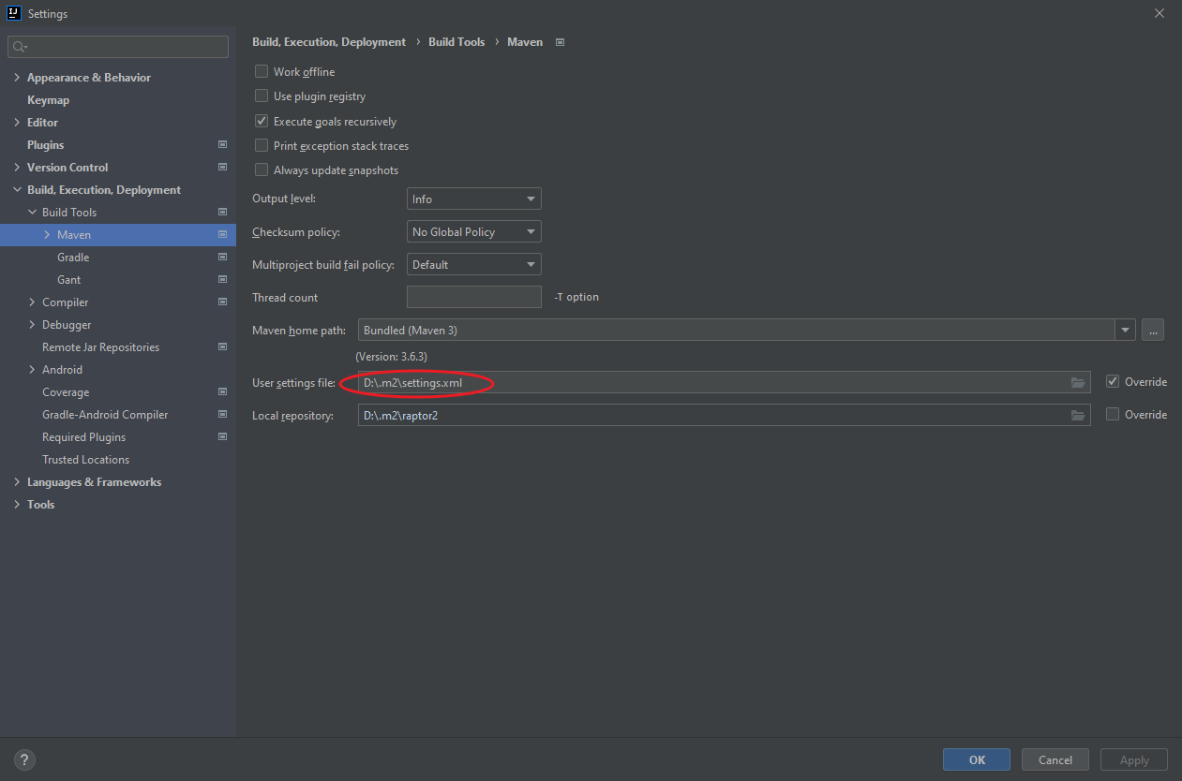

# FAQ

###### Setup 1.8 JDK but it builds as 1.4 or 1.5

close project

clean up .mvn folders

reopen project

###### Command too long

